Standard Operating Procedure

Purpose

A Non-travel Expense claim is created to track any expense(s) accrued by a University employee that is not related to travel (e.g. office supplies, lab materials, books/documentation, etc.) The document contains general information about the expense(s), along with the type(s) and amount(s) of expenses that occurred. After the Non-travel is complete, it will be routed to the designated Non-travel Expense Approver for processing by the approver.

Items Needed
- Personnel number for employee
- Original expense receipts
- Expense receipts scanned and saved as PDF’s. For instructions on scanning and attaching expense receipts, please click here.

Procedure
- Log in to Firefly using your User ID and Password. https://firefly.nebraska.edu/irj/portal/
- On the top menu bar, click on SAP Logon.
- Click the Launch SAP GUI icon.
- Under the Detailed Navigation menu on the left, click SAP Logon Production PC.
- If you are using the Standard Menu, the menu path is as follows:
  - Accounting ➔ Financial Accounting ➔ Travel Management ➔  Non-Travel Expense Manager
- If you are using the Simplified Menu, the menu path is:
  - Travel ➔ Non-Travel Expense Manager

NOTE: To switch between Standard and Simplified Menus, click the button on the toolbar with the green and red circles.
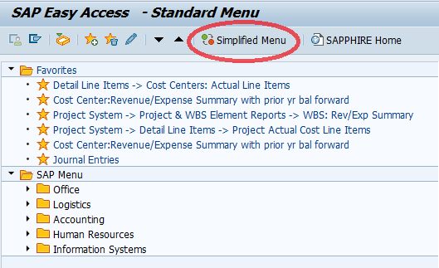

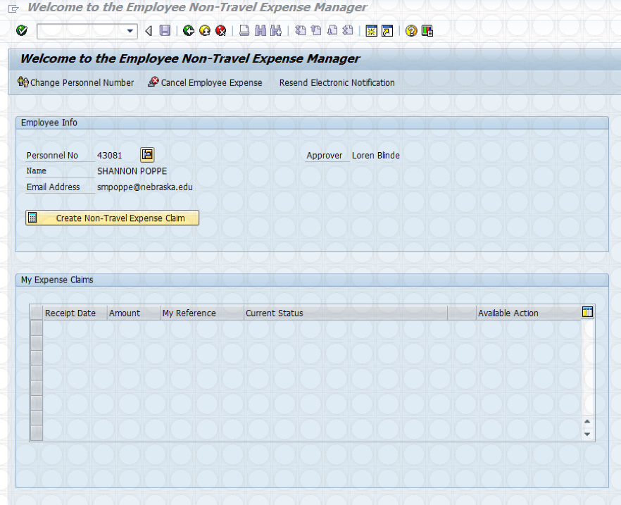
- Start the transaction using the menu path or transaction code.
- If you are submitting a Non-Travel Expense for yourself, leave the employee information as it is and click Create Non-Travel Expense Claim.
- If you are submitting a Non-Travel Expense for another individual, click Change Personnel Number in the upper left hand corner of the screen.
  - Enter the Personnel Number for the individual and click the green checkmark.
- As required, complete the following fields:

Field | Description
My Reference | Enter a title or reference for this non-travel expense claim.
Business Purpose | Enter the business purpose for the expense.
*Additional Comments | Enter any additional description or justification for this non-travel expense.
Receipt Date | Enter date the expense was incurred.
Amount | Enter the total amount of the expense. If there are multiple expenses on one claim, list each expense individually on a separate line.
Expense Description | Enter a detailed description of the expense.
*User Defined | Enter departmental detail/ requirement
G/L Account | Enter the appropriate G/L Account
Cost Ctr/WBS | Enter the cost center or WBS element that expense will be charged to.
*Denotes Optional Field

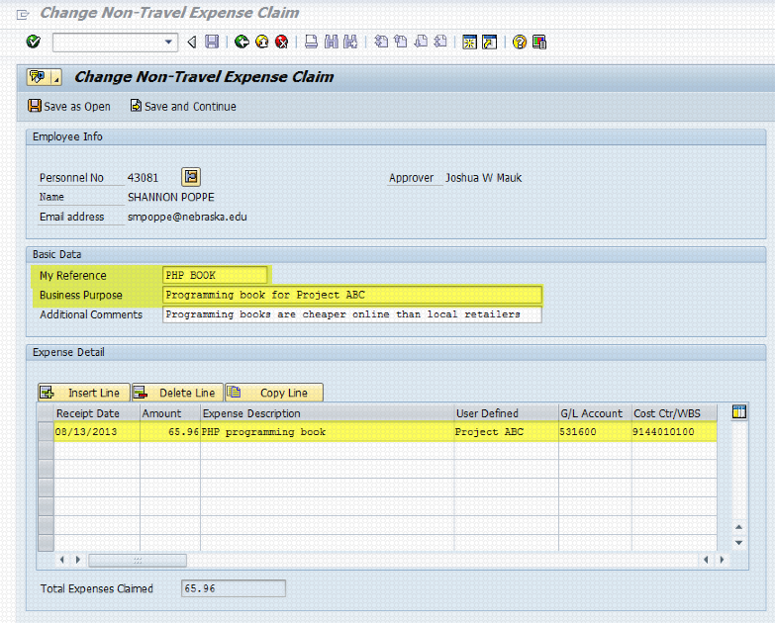
- Click to save your entries and return to the claim at a later time.
  - Upon clicking this button, you will return to the Welcome screen again. Click the Change Exp Claim link to open the claim for editing.
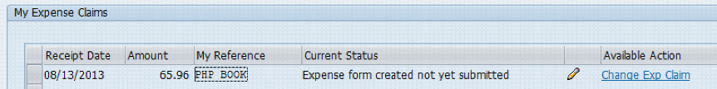
- Click if you have completed the claim and are ready to submit for approval. The Review and Attach Receipts screen will open.
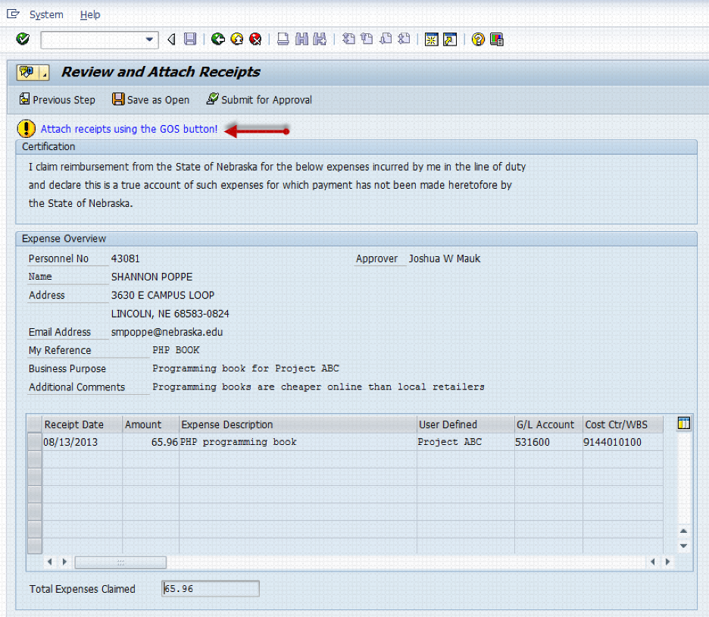

- If you hadn’t previously scanned your receipt(s), gather them now and scan them in a scanner using the guidelines listed here.
  - LASTNAME.MYREFERENCE (Employee Lastname – period – text that was entered in My Reference field; in ALL CAPS). Therefore the attachment, based on the step listed above, should be named POPPE.PHP BOOK.
- To create the attachment, click in the upper left hand corner and select Create Attachment. Browse and attach file by selecting the file and clicking Open.
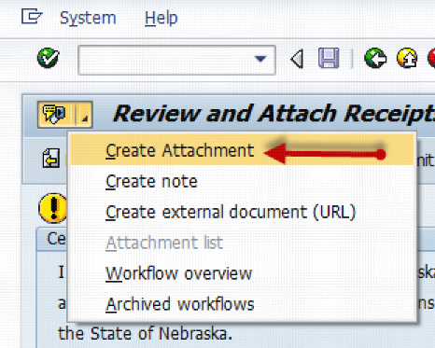
  - You will receive a green status message at the bottom of the screen if the attachment was created successfully.

- To verify receipts were attached, click again and select Attachment List. Note: you cannot change a file once it has been attached. If you attached the wrong file, contact Accounts Payable.
- If the expense is ready to be submitted, click the button. You will receive a green status message. Once a claim has been submitted for approval, workflow is kicked off. Your approved can approve, reject, send back for changes or delegate to another approver.
- The submitted claim will no longer be editable, but can be displayed (up until Accounting has posted the expense) by clocking the Display Exp Claim link on the Welcome page. 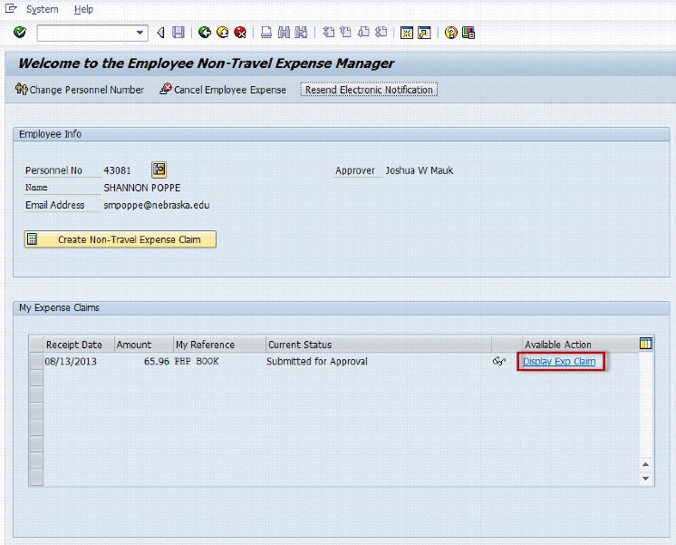

- You have completed the transaction.

- All reimbursements must be completed within 60 days of the expense being incurred. Reimbursements requested beyond this time period will not be reimbursed.

References

Definitions
Personnel Number: Identifying SAP personnel number

