10/26/2016
Moe Alahmad, Ph.D., P.E.
university of nebraska-lincoln

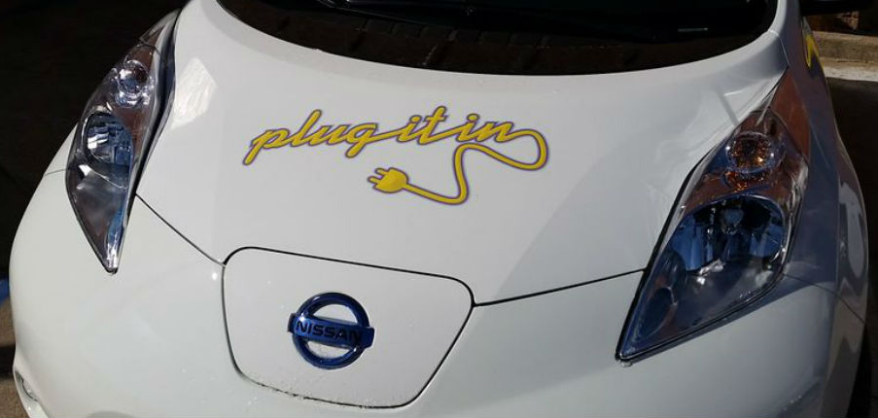
Nebraska Community Energy Alliance
Connecting Nebraska Communities Driving
America’s Fuel!
- Economic Savings Data for the Transportation Sector in Nebraska

ECONOMIC BENEFIT ANALYSIS for
NEBRASKA’s ALTERNATIVE FUEL VEHICLEs
Introduction
In this economic analysis we look at five types of alternative fuel vehicles:
- CV - Conventional Cars (Internal combustion Engine (ICE) Cars) running on gasoline fuel
- DV - Cars (Internal combustion Engine (ICE) Cars) running on Diesel fuel
- CNG – Trucks running on Compressed natural gas (CNG) fuel
- BEV – Battery electric vehicles (all electric) running a 100% on Electricity fuel
- HEV – Plug-in Hybrid electric vehicles (combination of electricity and gasoline fuel

- Economic benefits due to fuel type price differences

Data calculations are based on the following average prices and assumptions:
- Gas price of $2.43 per gallon (based on 2015 average [1]).
- Diesel price of $2.71 per gallon (based on 2015 average [1]).
- CNG price of $1.97 per gallon based on average CNG price by state. [2]
- Hybrid electric vehicles calculations are based on the vehicle using electricity only [3].
- Electricity price is dependent on the utility serving the cities in the study: there are four companies that supply power for the cities in this study, each with their own energy makeup and pricing:
  - Omaha Public Power District (OPPD)
  - Nebraska Public Power District (NPPD)
  - Northeast Nebraska Public Power District (NeNPPD)
  - Lincoln Electric System (LES)

The participating cities are shown in Table I with their service provider and the price per kilowatt. The price per kilowatt is based on the average commercial rate for each city provided by Electricity Local [4]. NeNPPD delivers power to Allen, Dakota County, and Wayne over NeNPPD transmission lines, but the electricity is generated by NPPD [5].

Table 1. Participating Cities and their electric rates bases on the service provider.
Participating communities | Provider | Price per kWh ($)
Allen Consolidated Schools | NeNPPD | 0.066
Ashland | OPPD (retail) | 0.094
Bellevue | OPPD (retail) | 0.094
Central City | NPPD (wholesale power supply) | 0.102
Dakota County | NeNPPD | 0.066
Ferguson House (Lincoln) | LES | 0.0706
Gothenburg | NPPD (wholesale power supply) | 0.081
Gretna | OPPD (retail) | 0.094
Hastings | Provides own service | 0.076
Holdrege | NPPD (wholesale power supply) | 0.092
Kearney | NPPD (retail) | 0.0889
Lexington | NPPD (wholesale power supply) | 0.0939
Lincoln | LES | 0.0706
Nebraska City | Provides own service | 0.1084
OPPD | OPPD | 0.084
Seward | NPPD (wholesale power supply) | 0.0935
South Sioux City | NPPD (wholesale power supply) | 0.0855
Valley | OPPD | 0.094
Wayne | NeNPPD | 0.0635

Table II shows the costs for driving one mile for each fuel type. The cost of fuel for a BEV is based on the price per kWh for OPPD, NPPD, NeNPPD, and LES calculated by averaging the data shown in Table I. Hastings and Nebraska City are not included in this calculation as these cities provide their own power. HEV is not shown in Table II since it has the same analysis as the BEV.

Table II: Cost for driving one mile.
 | CV | DV | CNG | BEV
 |  |  |  | OPPD | NPPD | NeNPPD | LES
Cost of “Fuel” | $2.43 per gallon | $2.71 per gallon | $1.97 per gallon | $0.092 per kWh | $0.091 per kWh | $0.065 per kWh | $0.0706 per kWh
Fuel Efficiency | 21.6 miles per gallon | 35 miles per gallon | 31 miles per gallon | 3.4 miles per kWh | 3.4 miles per kWh | 3.4 miles per kWh | 3.4 miles per kWh
Cost per mile | $0.11 | $0.08 | $0.06 | $0.027 | $0.0267 | $0.019 | $0.0208

Table III shows the cost savings for alternative fuel vehicles when compared with the Conventional vehicle (CV). The calculations shown are for driving one mile and then for driving an average 12000 miles (one year).
Table III: Cost savings for Alternative fuel vehicles when compared to CV.
 | CV | DV | CNG | BEV
 |  |  |  | OPPD | NPPD | NeNPPD | LES
Cost per mile | $0.11 | $0.08 | $0.06 | $0.027 | $0.0267 | $0.019 | $0.0208
Savings over CV per mile | -------- | $0.03 | $0.05 | $0.083 | $0.0833 | $0.091 | $0.0892
Estimated savings over CV per year | -------- | $360 | $600 | $996 | $999.60 | $1,092 | $1,070.40

Table IV shows the cost savings for driving BEV with varying gas prices. In this analysis, the price of gasoline varies from $1.5 to $3.00 in 50 cent increments. The table also shows the savings with the actual price of gas when the project was initially deployed in the summer of 2014. The calculations for the BEV prices are based on an average kWh price for OPPD, NPPD, NeNPPD and LES ($0.0234/kWh)

Table IV: Cost savings for driving BEV with varying gas prices.
Cost of Gasoline $/Gallon | $1.50 | $2.00 | $2.50 | $3.00 | $3.61 (Summer 2014)
Savings over CV per mile | 4.6 cents | 6.9 cents | 9.3 cents | 11.6 cents | 14.4 cents
Savings over CV per year (12,000 miles) | $552 | $828 | $1,116 | $1,392 | $1,728

- Economic benefits due to other factors effecting each fuel type
In addition to the fuel savings, additional cost savings for BEVs are attributed to car maintenance requirements. Table V shows the average maintenance cost for each type of car and calculates the yearly savings for the DV and BEV car type over the CV car type.
Table V: Cost savings calculations for DV and BEV due to maintenance and other savings. [6-8]
 | CV | DV | BEV*
Cost per mile | $0.0511 | $0.043 | $0.033
Cost per year | $613.2 | $516 | $396
Savings over CV per year | -------- | $97.2 | $217.2
*BEV’s annual maintenance are estimated to be 35% less than the maintenance requirement for CVs [9].

- Total economic benefits
Table VI shows the average combined fuel and maintenance cost savings for driving BEV in Nebraska.
Table VI: Total economic savings for DV and BEV car types over CV care type.
 | CV | DV | BEV
 |  |  | OPPD | NPPD | NeNPPD | LES
Cost per mile | $0.1611 | $0.123 | 0.06 | 0.0597 | 0.052 | 0.0538
Savings over CV per mile | -------- | $0.0381 | 0.1011 | 0.1014 | 0.1091 | 0.1073
Estimated savings over CV per year | -------- | $457.2 | $1,213.2 | $1,216.8 | $1,309.2 | $1,287.6

References
[1] https://www.eia.gov/forecasts/steo/report/prices.cfm
[2] http://www.cngnow.com/average-cng-prices/pages/default.aspx
[3] https://www.fueleconomy.gov/feg/label/learn-more-PHEV-label.shtml
[4] http://www.electricitylocal.com/states/nebraska/
[5] http://www.nnppd.com/about_us/profile/
[6] https://www.les.com/residential/rates/rate-schedules
[7] http://exchange.aaa.com/wp-content/uploads/2015/04/Your-Driving-Costs-2015.pdf
[8] http://www.vtpi.org/tca/tca0501.pdf
[9] https://www.fpl.com/environment/pdf/get-charged-up.pdf

