Standard Operating Procedure

Purpose

A Travel Expense report is created to track the total cost of a trip, both what an employee is to be reimbursed for and what the University has paid directly. The report contains general information about the trip, as well as the types and amounts of expenses that were incurred.

Items Needed
- Trip information
- Receipts from the traveler
- List of unallowable expenses found here.

Procedure
- The traveler will log in to Firefly using their User ID and Password. https://firefly.nebraska.edu/irj/portal/
- Under the Business Applications section, click on Concur Request, Booking & Expense.

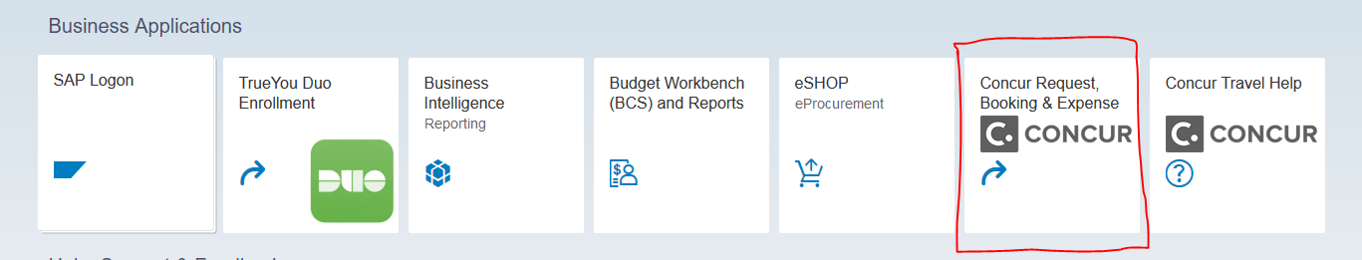

- Complete the Expense report, link it to the approved Travel Request, and submit the Expense report within 45 days of the last day of travel. https://nebraska.edu/-/media/unca/docs/concur-help/quick-reference-guide/create-an-expense-report.pdf

- The financial approver will log in to Concur, utilizing the same process as the traveler.

- Review the expense report to ensure its conform to the University Travel Policy; review proposed funding to ensure appropriateness. https://nebraska.edu/-/media/unca/docs/concur-help/quick-reference-guide/review-approve-an-expense.pdf

- After financial approval the Expense report is routed to A/P for their final review and release of payment.

- An email notification is sent to the traveler whenever an Expense report has changed status. This notification includes the new status (approved, sent back to user, sent for payment, etc.) and will contain comments from the approver if it was returned for changes. Note: When multiple approval steps are needed (e.g. supervisor, financial, international or use of state/charter plane) only one email is sent after the last approval step.

References
Campus Travel Policies and Procedures: https://nebraska.edu/-/media/unca/docs/brt/travel/NU_Travel_Policy.pdf

Definitions
Travel Request: a request to travel on University business, to be submitted and approved prior to the travel or the incur of any travel expenses

A/P: Accounts Payable

