Standard Operating Procedure

Purpose

A Travel Request is created to grant permission to travel and to track the total expected cost of a trip. The report contains general information about the trip, as well as the types and amounts of expenses that are expected to be incurred. Expected costs include what an employee is to be reimbursed for and what the University will directly pay. The Travel Request should be submitted and approved prior to the trip starting. Travel costs should not be incurred until after a Travel Request is completely approved.

Items Needed
- Trip information
- Expected costs
- List of unallowable expenses found here.

Procedure
- The traveler will log in to Firefly using their User ID and Password. https://firefly.nebraska.edu/irj/portal/

- Under the Business Applications section, click on Concur Request, Booking & Expense.

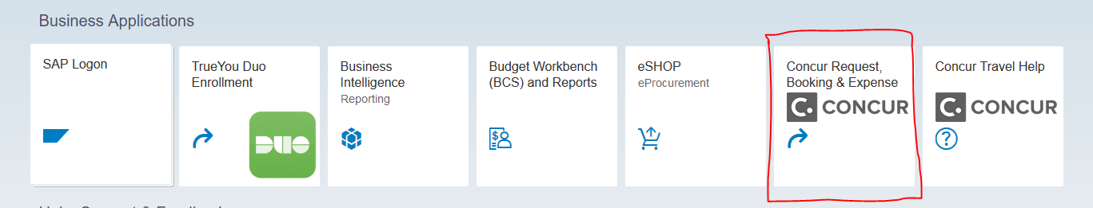

- Complete the Travel Request and submit. International Travel Requests should be submitted 30 days in advance of the trip. https://nebraska.edu/-/media/unca/docs/concur-help/quick-reference-guide/create-and-submit-a-travel-request.pdf

- The supervisor approver will log in to Concur, utilizing the same process as the traveler.

- Review the Travel Request to ensure it is for approved University business. https://nebraska.edu/-/media/unca/docs/concur-help/quick-reference-guide/review-approve-travel-request-supervisor.pdf

- The financial approver will log in to Concur, utilizing the same process as the traveler.

- Review the Travel Request to ensure its conform to the University Travel Policy; review proposed funding to ensure appropriateness. https://nebraska.edu/-/media/unca/docs/concur-help/quick-reference-guide/review-approve-travel-request---financial.pdf

- If it is international travel the Travel Request is routed to the EVC office for their final review.

- An email notification is sent to the traveler when the Travel Request has changed status. This notification includes the new status (approved, sent back to user, etc.) and will contain comments from the approver if it was returned for changes.

- The traveler may make travel arrangements and incur costs once the Travel Request is approved.

- Travel costs, including those incurred before the trip, will not be reimbursed until after the last day of travel.

References
Campus Travel Policies and Procedures: https://nebraska.edu/-/media/unca/docs/brt/travel/NU_Travel_Policy.pdf

Definitions

EVC: Executive Vice Chancellor

