Standard Operating Procedure

Purpose
Creating a Goods Receipt: A goods receipt must be entered against the purchase order that initiated the order. The goods receipts also acts as the approval for accounting to pay the invoice.

Items Needed
- Requisition form or email with detailed description from purchaser, containing the PO from original order; AND
- Invoice with the packing slip containing items, quantities received, and PO number.
- Menu Path in SAP
  - Transaction Code ZORDER - Goods Receipt or MIGO
    - Standard Menu:
      - Purchase Order - MM Launchpad - Goods Receipt
    - Simplified Menu:
      - Purchasing/Accts Payable - Logistics Launchpad - Goods Receipt
- FireFly-eSHOP access

Procedure
Creating Goods Receipt in SAP
- Start the transaction using the menu path or transaction code: (zorder)
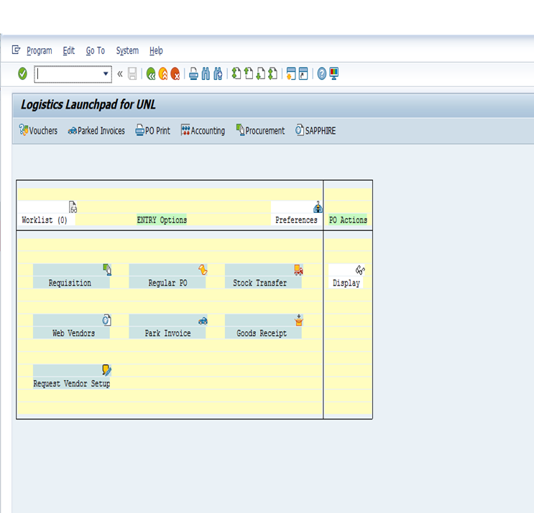
- Complete/review the following fields
  - Purchase order> Ex: 4500126465
  - Goods Receipt> 101-Goods receipts (most used) or 102 – Reversal of Goods Receipts
- Click Execute or press Enter
- Complete/Review the following fields
  - Document date> enter the date on the vendors packing list
  - HeaderText> enter header test pertinent to receipt (event, grant, or identifiying title)
  - Check box
  - Make sure Material Quantity/Where Box is minimized or you will not be able to check the box
- Click in the OK column if you have received some or all of an item
- Complete/Review the following fields
  - Qty in UnE> the outstanding PO quantity will be proposed. If necessary, change the quantity in this field to reflect the actual quantity of items received.
  - Unloading Point> Defaults from the purchase order, but change if necessary

- Click Post> the system displays the message “Material document 51XXXXXX posted” in the status bar or dialog box

- Goods Receipt is completed, in RED INK, write the cost center/WBS number, GL account, Goods Receipt #, okay to pay: full name signature, and date in the top right corner of the invoice.
    - Note: if you do not have the invoice (only receiving documentation) at the time of creating the goods receipt, wait for it to arrive, then complete processing the invoice.

Creating a Goods Receipts in eSHOP

- Launch eSHOP> Log into FireFly and click eSHOP on the top banner. In the top right corner click Launch eSHOP

- Locate the search icon in the top right corner. Type in the PO.
- Under Available Actions, select create quantity receipt and click go.

- Complete/Review the following fields
  - Receipt Date
  - Packing slip No (may not be available)
  - Receipt Address> select NTC
  - Delivery Information
  - Quantity received
  - Line Status> select received if all or partial items were received; also have the option to remove a line item, receive & return items.

* Be sure to compare the item number, quantity, and pricing from the PO in SAP to the invoice. This must match in order to be paid properly.
- Click complete (If vendor sends invoice to NTC instead of Central accounting, NTC should forward to Central accounting for payment)
- Scan packing list into eshop for documentation

References
Firefly > Sapphire > Documentation > Procurement >
- Accounts Payable > Goods Receipt > Create Goods Receipt (MIGO)
GL Account Codes: https://sapphire.nebraska.edu/gm/folder-1.11.16003?mode=EU&originalContext=1.11.13880

Definitions
PO: Purchase order number
WBS: Work breakdown structure- 13 digit number that describes a source of funds (grants)
Cost Center: 10 digit number that describes a source of funds
GL Code: General ledger accounting code, categorizes the type of purchase (supplies, postage, etc.)

