Standard Operating Procedure

Purpose
Our copier machines are paid for on a cost per copy basis. We have to report our usage to the Cost per Copy Administrator monthly. You will receive an email around the 10th of each month, prompting you to enter your meter readings for the month via a web-link provided in the email. The link will accept entries from the 10th through the 20th of the month. If email is not received contact Cost Per Copy Program and request the link.

Items Needed
- Email from Thomas Jochum (tjochum2@unl.edu)
- Machine ID for each copier
  - 262Q – JC1S7
  - SAP 262Q – JC0OF
  - 330A – JC0P0
- Default password (abc123)

Procedure
- Grab paper and pen. Walk to the copier.
- To log in to any of the 3 copiers, enter your Department ID and Pin Number and hit the Log In button.
Department ID: 5468468
Pin: 2541967
- Press the “Counter Check” button on the main panel. This opens the Copy Count screen to the left.
- Note the number on the upper left of the display screen (Total 1). Write this number in the designated space on the spreadsheet in the CPC file folder. Also fill in the number for Total Blk.
- Select the “Send/Fax Cntr Check” button. This will open the Scan Count screen.
- Write the totals for Blk Scan and Color Scan on the spreadsheet in the designated spaces. To get your total scan count, you will add the numbers shown on the lines labeled “Black and White Scan (Total 1)” and “Color Scan (Total 1)”.
- Complete this process for all three copiers.
- Open the email from Thomas Jochum and click on the web-link provided.
- Log in with the Machine ID and password provided above for 262Q copier.
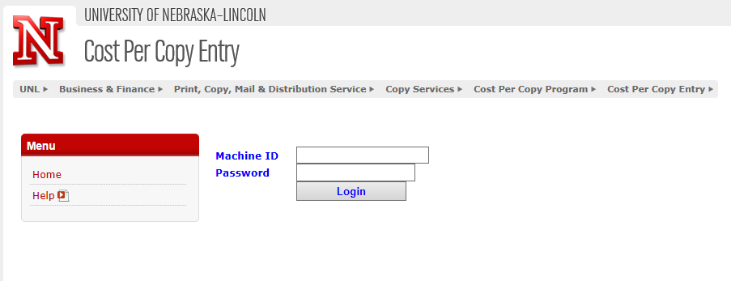
- A screen will appear with the previous month’s data, as well as fields to enter the current month’s numbers.
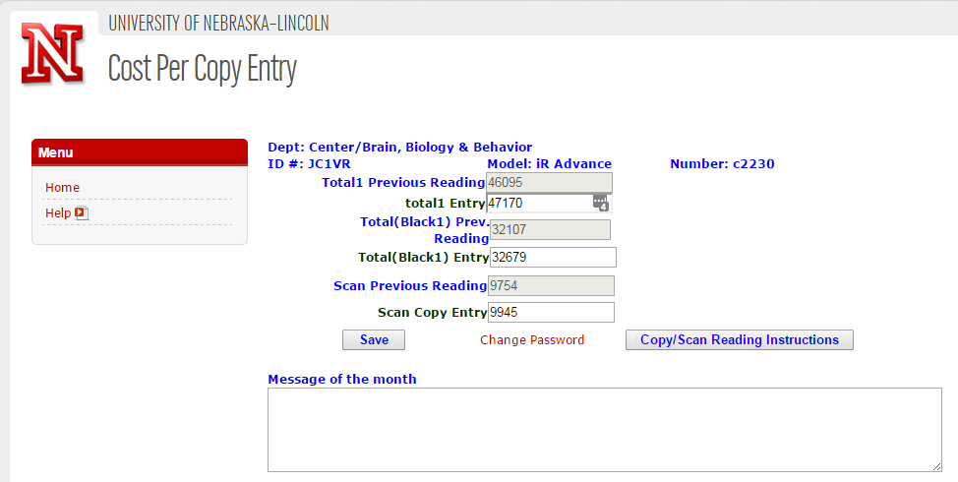
- Enter the usage for the respective machine and click Submit.
- A message will appear confirming the information you entered and will give you the cost for the copies made during the month. If correct, print the page to a PDF and click Yes.
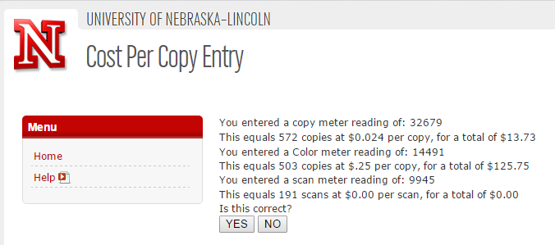
- An invoice appears. Send a pdf of the invoice along with a PDF of the entry data to the College of Engineering business office for reconciling documentation.
- Click ok and the system will direct you back to the Home screen. Enter the Machine ID and password provided above for the other two copiers. Repeating steps 10-13 for each.

