Nd:YAG laser operation
a) Turn on
1. Turn on the water supply and plug on the power source;
2. Turn on the switches from bottom to top (power switch — CPU switch —Key switch);
3. Wait for 6 seconds until the ‘Manual Mode’ shown on the viewing screen;
4. Press ‘Auto/Manual’ which will display PGM1, then press ‘Active’ to active PGM1 for warm-up;
5. Press ‘Start’ to start to warm up the laser system;
6. After 30 minutes, press ‘Stop’ to end the system warm up progress.
b) Operation
1. The pump energy is very important to this OPO laser system. Too higher pump energy will damage the OPO crystals; too lower pump energy will get rather low output energies. The optimized pump energy is around 250 mJ/pulse, which we need to choose PGM3 (185µs delay) to get.
2. Wavelength adjustment. Input your target wavelength value in the ‘GOTO’ column first and then click ‘GOTO’ button will make the system to the target wavelength.
3. Output energy optimization. To optimize the output energy, only SHG1 and SHG2 positions are allowed to adjust. NOTE: Never adjust Osc, Comp and Prism positions. In daily operation, never click save buttons as indicated in the following figure. These ‘SAVE’ buttons will modify the originally stored calibration files for the system. Inappropriately modified calibration files will cause the system output energy to zero.
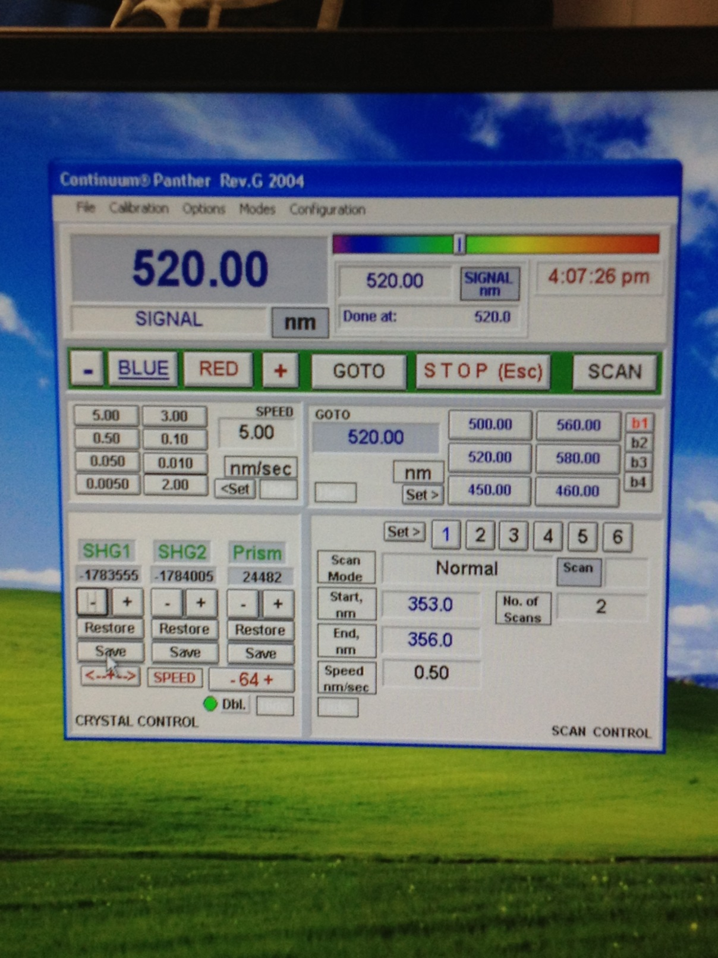

c) Turn off
1. Click ‘Restore’ buttons before exiting the software if you have adjusted the SHG1 or SHG2 positions.
2. Exit the software.
3. Turn off the laser.
4. Turn off the water supply and plug off the power source.
Safety
1. Always wear googles with laser operation.
2. Use low energy for optical alignment for safety.
3. Always to turn on and off the cooling water system for equipment safety.

