Laser marking system (cw) Operation Instruction:
- Turn on the Key at the front side of Laser;
- Then turn Power button at the back of Controller.
- Then turn the key on at the front side of Controller.
- Open the Waverunner software in Computer.
- Remove the lens cover from Scanner head.
- Design the structures using the Waverunner.
- Start writing.
Controller
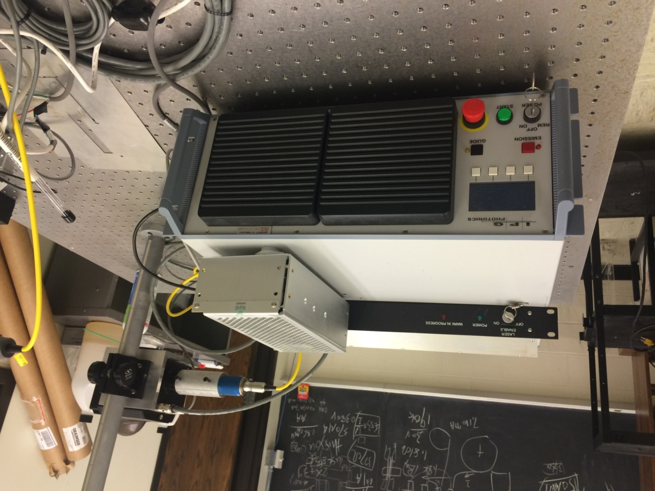
- Safety: Goggle required.
Scanner
Laser

