Laser marking system (Pulsed) Operation Instruction:
- Turn on the Power button at the back of Controller;
- Then turn the key on at the front side of Controller.
- Open the Waverunner software in Computer.
- Remove the lens cover from Scanner head.
- Design the structures using the Waverunner.
- Start writing.
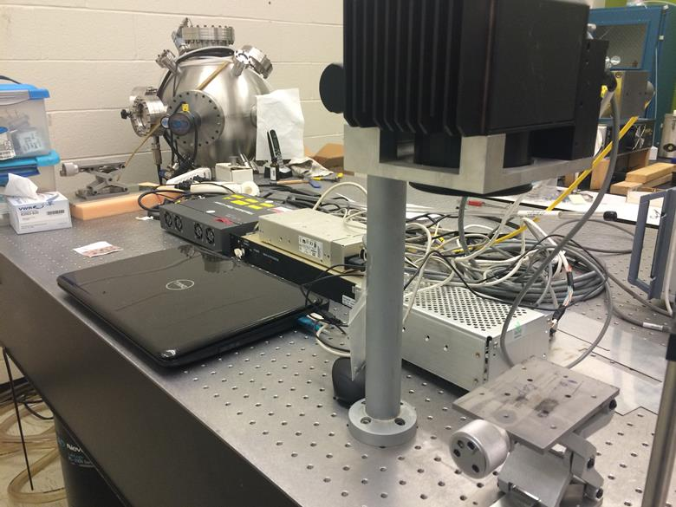
- Safety: Goggle required.
Laser
Controller
Computer
Scanner

