Welcome to the temperature and dew point analysis calculator.
This document is to serve as a user manual for what to expect to learn from it and how it works.
The calculator was created from the need to decide how many days a damper to the outdoors could be opened to cool an area with equipment that is generating heat. While cooling, the humidity needs to also remain below a certain specified threshold without any dehumidifying devices. To find that, the observer must decide on what indoor temperature they are aiming for and what relative humidity (RH) they must stay under.
For example, imagine a room with electrical equipment that is constantly generating heat. The room has air conditioners that run to cool the room year-round. Instead of running the conditioners year-round, energy can be saved by opening dampers during cooler months. Air handling units (fans) would then draw the air in from outdoors and push it into the room for cooling purposes. Since electrical equipment is sensitive to humidity, days with low temperatures but high humidity would need to be removed from the data pool.
The primary function of this excel file is for the user to be able to easily view the trends of temperature and humidity of a particular region over a year’s period. This calculator works as intended when the situation being analyzed is using raw, unconditioned outside air and pumping it inside for cooling purposes. The most important aspect to understand is that the inside RH is calculated from assuming that the dew point of air outside equals the dew point of air inside since there will be no dehumidifiers present. Since the air is not conditioned in any way, the dew point remains the same inside.
However, the temperature is warmer inside due to equipment outputting heat into the inside room. This combination creates a unique relative humidity inside the room; one we want to monitor.
The user inputs historical weather data from the region; maximum, average, and minimum temperatures and max, average, and min dew points. This data can be found and copied easily into the cells from Weather Underground. The calculator then outputs indoor RH, outdoor RH, along with two graphs to show yearly trends. Two threshold lines can be moved around to set the “limit” of what is acceptable. By either quickly approximating or counting the number of data points under the lines, the user can find the quantity of days that fall below both the temperature and dew point lines and thus can be counted as a day a damper could be opened.

Follow the steps below to get started.
Note: Download the calculator first. Do not use the original. It does not work unless you have a downloaded copy on your computer.
Before we start, please note the different cells and what they mean. Not every cell is for input.
  - Input cell
  - Output cell
  - Linked cell (cell takes an input, but is entered elsewhere)
  - Normal cell (do not change)
- Identify the region of the facility you are working with and go to the history tab on the Weather Underground website. Scroll down to see the data. You will be copying the data into a blank excel sheet,
  - 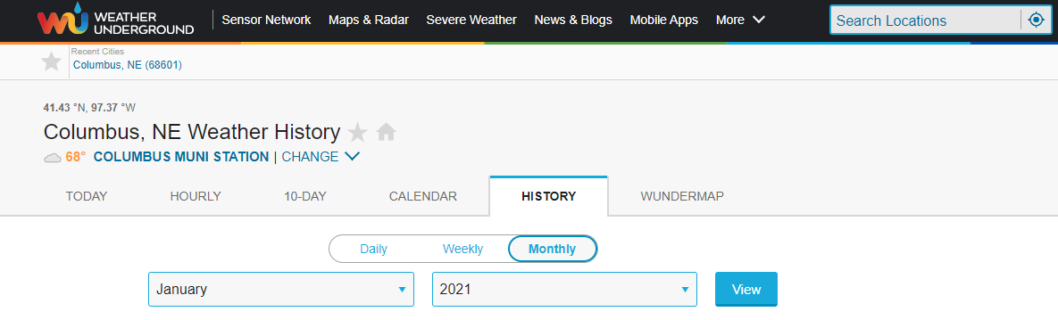
- Copy the data by selecting from the top of time down to the bottom of dew point as shown. It’ll look something like this. Don’t worry about humidity, the software will calculate it too.
  - 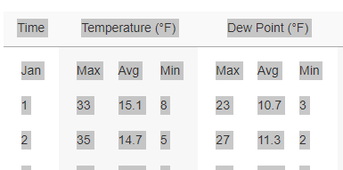
  - 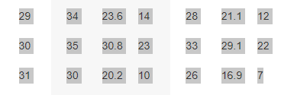
- Open the calculator and paste the data into the Weather Data Copy Page sheet of the excel file. An example paste is in there already. Just overwrite it.
  - 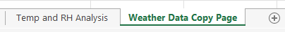
- Copy the previously pasted data, but only from the max temperature (33 currently shown) cell over to the min dew point cell (3 currently shown) and down the entire column. Zoom in on this document to see it better. The bolded and underlined data is what you want. Ignore the rest. Everything else is just a placeholder for the next set of data or a casualty of copying from the website that gets pasted in regardless.
  - 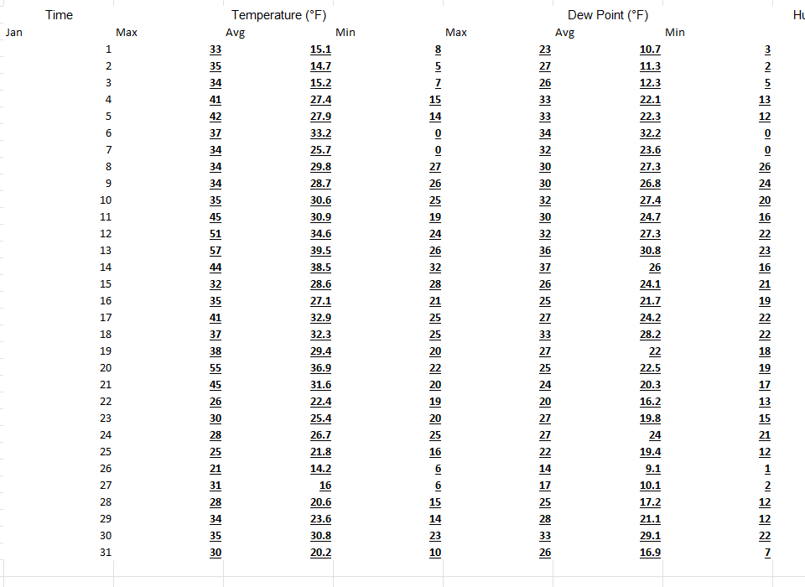

  - Paste over the data from January to December in the same fashion. Don’t worry if the cells color and format changes, this won’t affect anything. It is setup orange to help you identify where it goes. You should be copying six columns and anywhere from 28 to 31 rows depending on the month.
  - 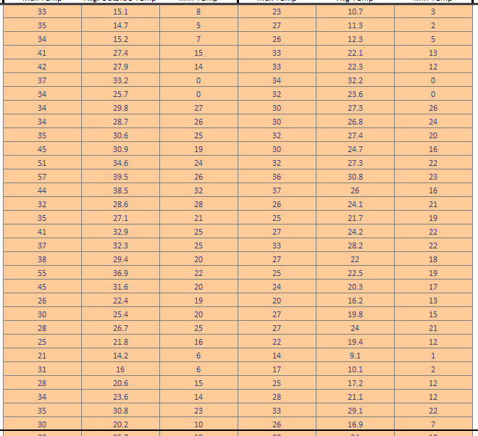
  - When you paste it in, it’ll look something like this. You may test this process by copying the data already set in and pasting it into the cells. If the graphs don’t change, you did it correctly. It’s the same data that is already in there now.
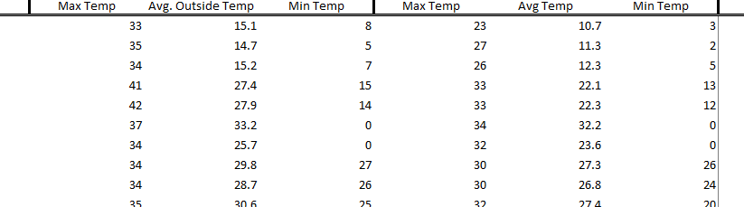

- Identify the average indoor summer and winter temperatures that the room aims to achieve. Input them into the calculator here. The linked cells will update with this. Note that the year is split up into two sections: summer and winter. The cells are pre-defined.
  - 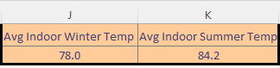
- Set your threshold lines and start counting. The number of days under the lines are the days the facility can use outdoor air for cooling. Note there are two y-axis: one for temperature and the other for humidity. Blue goes left and orange goes right.
  - 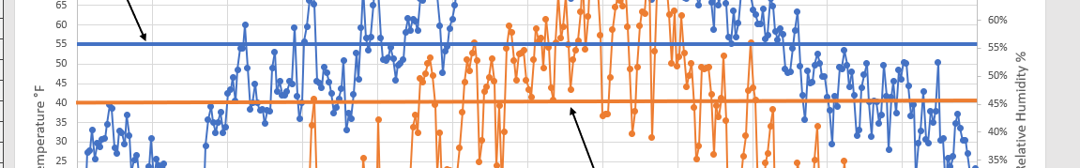
Good luck on your recommendations! Hope this tool helps you as well as it did me.

https://www.wunderground.com/history/monthly/us/ne/columbus/KOLU/date/2021-1

