Personalized Instruction Review Report
May 14, 2019

Personalized Report for Sample2

COPUS
Smith et. al (2013) developed a teaching observation procedure known as the Classroom Observation Protocol for Undergraduate STEM or COPUS. This protocol allows STEM faculty, after a short 1.5-hour training period, to reliably characterize how faculty and students are spending their time in the classroom.
Observers attend a course mulitple times (50 minutes each) and used a COPUS form to mark behaviors in 2-minute intervals.
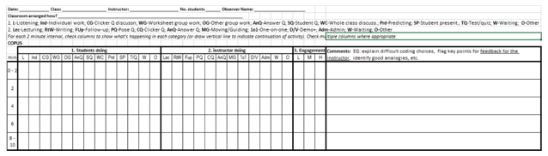
The protocol has 3 main parts as listed below:
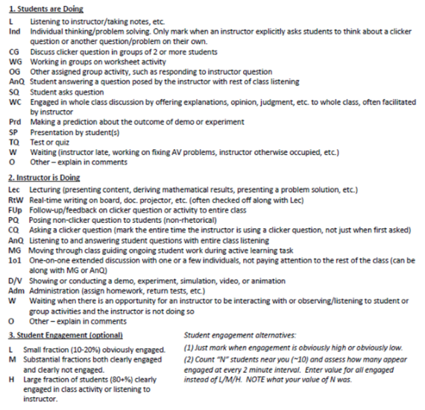
When interpreting the data generated from COPUS, the activities listed above under “Students are Doing” and “Instructor is Doing” are collapsed into 8 categories (4 for students and 4 for faculty). For students:
- “Receiving” is indicated by the code “L”.
- “Working” is indicated by the codes “Ind,” “WG,” “OG,” “Prd,” and “TQ”.
- “Talking” is indicated by the codes “CG,” “AnQ,” “SQ,” “WC,” and “SP”.
- “Other” is indicated by the codes “W” and “O”.
For faculty:
- “Presenting” is indicated by the codes “Lec,” “RtW,” and “D/V”.
- “Guiding” is indicated by the codes “FUp,” “PQ,” “CQ,” “AnQ,” “MG,” and “1o1”.
- “Administrative” is indicated by the code “Adm”.
- “Other” is indicatd bye the codes “W” and “O”.

Instructional Profiles
Based on Stains et. al (2018)’s research, analysis of COPUS observations results in three main categories (Instructional profiles) represented by 7 clusters as shown below.
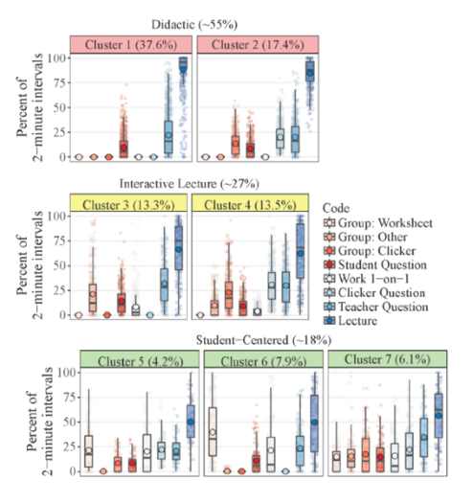

Your Results
Based on the observations conducted in ENGR 201 on 2/2/2019 and 3/2/2019, the data analysis resulted in the following:

1. Instructional Profiles
The first observed course session was classified as 3, and the second was classified as 4.
Cluster 3 falls under Interactive Lectures. This mode of instruction supplements lectures with student-centered strategies. Cluster 3 might contain clicker questions that are sometimes associated with group work.
Note. Student activities are shown in blue/purple, and instructor activities are shown in red/orange. Darker shading indicates more activities from that category occurred during the 2-minutes period. Category components are given with the explanation of COPUS above.
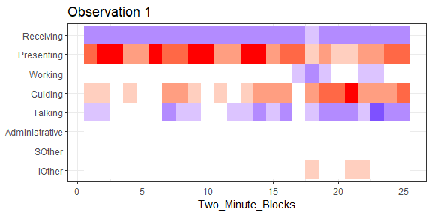
Cluster 4 falls under Interactive Lectures. This mode of instruction supplements lectures with student-centered strategies. Cluster 4 represents lectures with clicker questions and group work.
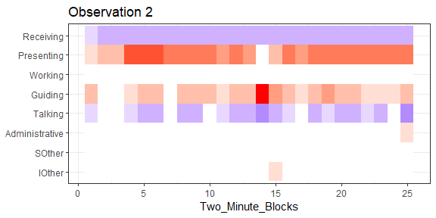
The next chart shows how your COPUS results compare to the results from all other instructors who were observed this semester.
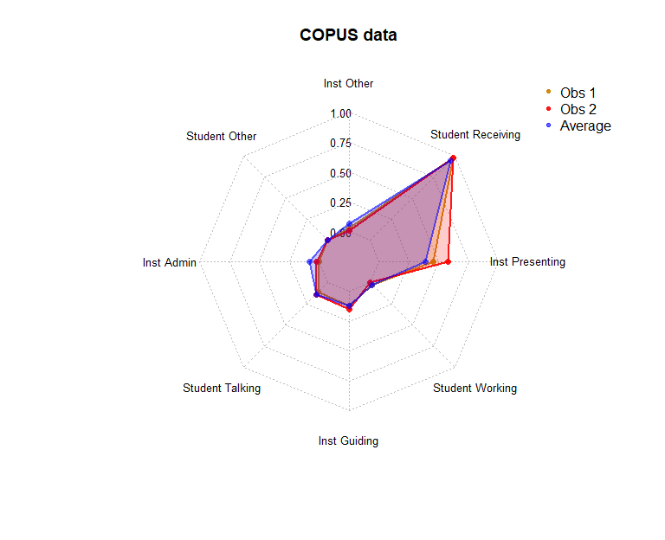

2. Teaching Practices Inventory
This inventory can aid instructors and departments in reflecting on their teaching. It has been tested with several hundred university instructors in STEM fields. Inventory results can be used to gauge the extent of use of research-based teaching practices. Keep in mind that no single course is expected to incorporate all of the things listed in the TPI and there is no single formula for high-quality instruction.
This chart shows a high-level comparison of how your responses to the TPI compare to those of other faculty in the college. The scoring of the TPI gives more weight to practices that are shown by research to be more beneficial to student learning. The perimeter of the chart represents the maximum possible value for each category.
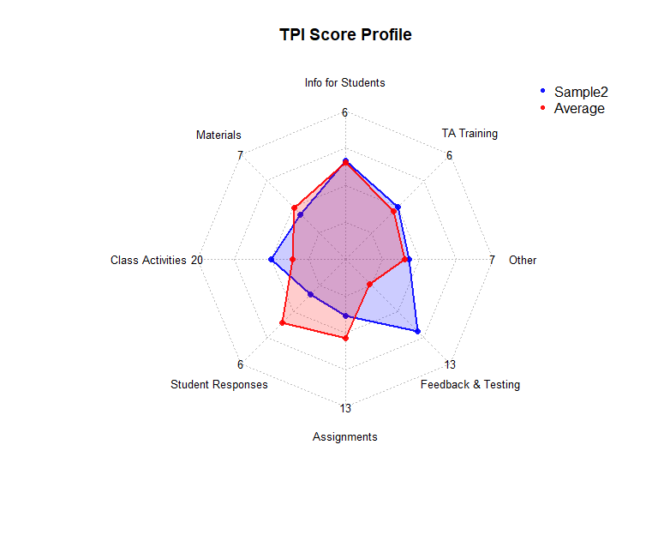
- For Information for Students, you scored 4 out of 6. Your practices in this area are likely benefitting students, but there are likely ways to expand what you are already doing.
- For Supporting Materials, you scored 3 out of 7. Your practices in this area are likely benefitting students, but there are likely ways to expand what you are already doing.
- For In-Class Activities, you scored 10 out of 20. Your practices in this area are likely benefitting students, but there are likely ways to expand what you are already doing.
- For Individual Student Responses, you scored 2 out of 6. This area presents an opportunity for improvement.
- For Assignments, you scored 5 out of 13. Your practices in this area are likely benefitting students, but there are likely ways to expand what you are already doing.
- For Feedback and Testing, you scored 9 out of 10. This is an area of strength for your teaching.
- For Other, you scored 3 out of 7. Your practices in this area are likely benefitting students, but there are likely ways to expand what you are already doing.
- For TA Training and Guidance, you scored 3 out of 6. Your practices in this area are likely benefitting students, but there are likely ways to expand what you are already doing.

Recommendations

COPUS
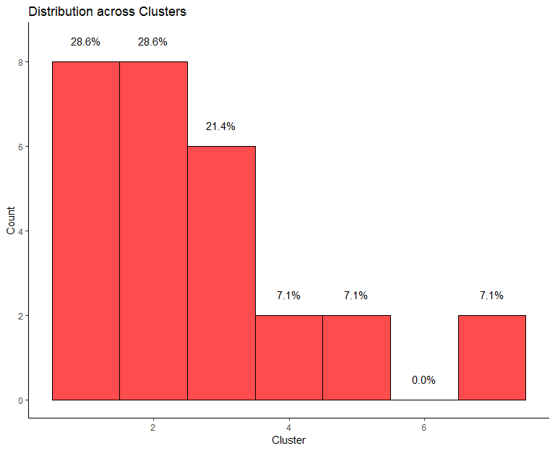
This chart shows the number of College of Engineering faculty whose observed course sessions were classified into each of the seven clusters. Our goal is to have fewer than one third of courses sessions classified as a 1 or a 2. Your observed course sessions were 3 and 4.
Based on these classifications, you seem to incorporate student interaction and activity into your courses. Good work! If you’re interested in trying new instructional techniques or expanding what you are already doing, the ECEC can help.

TPI
All of the practices highlighted in this section are evidence-based practices we strongly encourage instructors to use. What follows is a comparison between what you reported and what other instructors in the College of Engineering have reported.

Information for Students
You indicated that you do provide students a list of topic-specific competencies students should achieve in the course. About 68.75% of instructors in the college who have taken the TPI reported providing a list of topic-specific competencies.

Supporting Materials
You indicated that you do provide students with solutions to homework assignments. About 68.75% of instructors in the college who have taken the TPI reported providing solutions to homework assignments.
You indicated that you do not provide students with worked examples of sample problems About 62.5% of instructors in the college who have taken the TPI reported providing worked examples.

In-Class Activities
You indicated that you pause to ask students questions about 4-6 times per class. On average, instructors in the college who have taken the TPI reported pausing to ask students questions about 4-6 times per class.
You indicated that you have students discuss or solve problems in groups an average of 2-3 times per class. On average, instructors in the college who have taken the TPI reported having students discuss or solve problems in groups 1 time per class.
You indicated that you do have students complete assignments or quizzes near or at the start of class over material they were to view before class. About 50% of instructors in the college who have taken the TPI reported using this practice.
You indicated that on average you lecture 40-60% of the class period. Instructors in the college who have taken the TPI reported lecturing 40-60% of class periods.

Individual Student Responses
You indicated that you pose a question to students and then have them engage in discussion 1 time per class. On average, instructors in the college who have taken the TPI reported having students engage in discussion following a question 1 time per class.

Assignments
You indicated that you do assign graded homework at least every 2 weeks. About 93.75% of instructors in the college who have taken the TPI reported assigning graded homework at least every 2 weeks.

Feedback and Testing
You indicated that you do let students see graded assignments and you do let students see graded quizzes/exams. Of the instructors in the college who have taken the TPI, 100% reported letting students see graded assignments and 75% reported letting them see graded quizzes/exams.
You indicated that you do let students see the answer keys for graded assignments and you do not let students see the answer keys for graded quizzes/exams. Of the instructors in the college who have taken the TPI, 75% reported letting students see the answer keys for graded assignments and 37.5% reported letting them see the answer keys for graded quizzes/exams.

Other
You indicated you do not use a consistent measure of learning that can be used to compare learning across sections and semesters. About 6.25% of instructors in the college who have taken the TPI reported using a measure to comparing learning across sections and semesters.
You indicated that you do provide opportunities for students to self-evaluate their learning. About 43.75% of instructors in the college who have taken the TPI reported providing opportunities for self-evaluation.

TA Training and Guidance
You indicated you do not have TAs for this course.

Next Steps

Contact the ECEC:
Email us as engr-ecec@unl.edu or visit the ECEC website
Our Instructional Designers can help you:
- incorporate more evidence-based strategies into your courses
- design, develop, implement, and evaluate new learning activities and innovative pedagogies
- integrate instructional technology into your teaching to enhancing learning
Our Learning Assessment Coordinator can:
- review your classroom assessment processes and provide recommendations
- teach you how to evaluate the quality of your classroom assessments
- help you develop new classroom assessments
Our ongoing faculty programs include:
- Learning by Design - learn the Backwards Design process as you develop or redevelop a course
- Teaching Evaluation - get feedback on your teaching and learn about how other instructors in the college approach teaching

