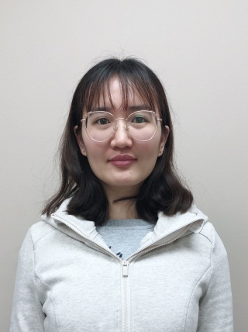

Liujun Wu
Graduate Student
Email: jun561992@163.com
Phone: 4024801958

Education
Ph.D.: School of Mechanical Engineering, Jiangsu University, China, 09/2016-Present
M.S.: School of Mechanical Engineering, Jiangsu University, China, 09/2014-08/2016
B.S.: School of Mechanical Engineering, Jiangsu University, China, 09/2010-06/2014

