Partners in Pollution Prevention (P3)
Intern Program

Application Instructions

Application Requirements
- Applicants must be enrolled in an accredited engineering or science program at a U.S. college or university.
- Applicants must have at least Junior standing by the start of the summer. Preference is given to students with Senior standing.
- Applicants must have completed coursework in chemistry and calculus (Math 106 at the University of Nebraska-Lincoln [UNL]). Completion of an environmental engineering course or basic manufacturing course is desirable.
- Applications must be received by 4 pm on Friday, February 1, 2019. Applications received early, by Friday, January 25th may be reviewed, and select applications may be shared with clients before the final deadline.

Instructions
- Complete all information requested on the application form.
- Answer all the Supplemental Application Questions.
- Submit a current one-page resume with the completed application.
- Include a copy of your university transcript(s) Note: unofficial transcript(s), photocopies, or a self-generated listing of courses and grades will be accepted; official transcripts may be required prior to the program starting date.
- Obtain two references using the forms provided or letters of reference. One should be a university faculty member; the other may be a supervisor or someone familiar with your work habits and personality. Please have the person providing the recommendation return the form either by mail or e-mail to the addresses below. Often students provide their reference person with a pre-addressed envelope.

If You are Selected to the P3 Program
- If you are a non-UNL student, the procedure for admission to UNL as a Visiting Student is expected to be completed in a timely manner.
- It is the responsibility of non-University of Nebraska students to gain approval for the transfer of credits and to pay any transfer credit fees at their home institution. A brief course description is available on the Web site to use in obtaining transfer credit.
- Participants are required to have coverage under a health insurance plan and to furnish proof of such coverage at the start of the program. Health insurance fees are the responsibility of the participants.

Submit Your Completed Application to: P3 Intern Program
N120 SEC Link
Lincoln, NE 68588-6105
Or e-mail to: bdvorak1@unl.edu
Application Checklist: Completed application form
Resume
Answers to Supplemental Questions (Description of Interest)
Transcripts
Reference letters (2)
General Information and Inquiries: Dr. Bruce Dvorak, P3 Program Director at 402/472-3431
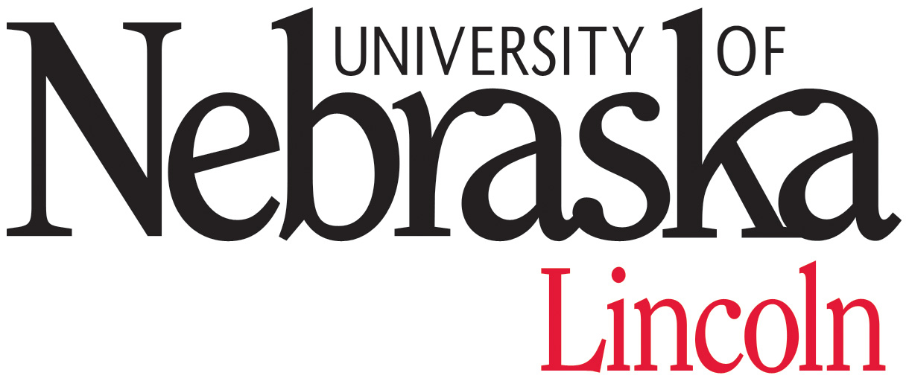
For more information on the P3 program, visit our website at http://www.p3.unl.edu.

Partners in Pollution Prevention Intern Program APPLICATION

Please type or print in black ink.

Name: _______ ______________________ ___ ____________________________________
Mr./Ms. First M.I. Last

Current Address: ________________________________________ ( )______________
Street Telephone This is my Cell Phone
_____________________ _____ ______________
City State Zip

Permanent Address: ________________________________________
Street
_____________________ _____ ______________ ( )_________________
City State Zip Telephone This is my Cell Phone

E-mail address: ____________________________________ Date of Birth: _______________________________

UNL Student I.D. Number: ____________________________________

U.S. Citizen or Permanent Resident Alien: Yes No

Gender: M F

Emergency Contact: ____________________ ________________ ________________ ___________
Name Home Telephone Work Telephone Relationship

College/University Attended  Name and Location | Dates Attended | Degree Expected or Received | Expected Graduation Date

Academic Major: ____________________ GPA _________ Math/Science/Engr. GPA _________

Present Class Standing: Junior Senior Graduating Senior Graduate Student

I affirm that the information in this application is accurate to the best of my knowledge. I also give permission to share the information in this application with potential P3 program business clients.

________________________________________________ _____________________________
Name/Signature Date

INCOMPLETE APPLICATIONS WILL NOT BE CONSIDERED

Supplemental Application Questions

Description of Interest

Please provide a typed description of your interest in the P3 program on an additional sheet of paper by answering all the questions below. Number your responses to each of the seven questions. Limit your answer to each question to no more than a paragraph. Several questions can be answered with a single sentence or phrase. Each P3 internship position is different. This information helps us learn about you and identify possible intern placements.

- Why do you want to be part of the P3 program?

- What qualifications do you have that will help you to succeed in the P3 program? These qualifications may include your course work, volunteer and work experience, work habits, personality traits, interests or hobbies away from school, environmental ethic, etc.

- This program is unique in that it provides a number of different learning experiences. What are the top two or three areas/topics that you want to be personally challenged to improve by participating in the P3 learning experience? Briefly explain. Examples of topics include (but are not limited to): pollution prevention theory/methods, sustainable manufacturing, energy efficiency, food processing, technical writing, applied research, interpersonal communications, time management, and making public presentations.

- We place students throughout the state of Nebraska in both rural and urban areas. Note that the majority of positions are for clients outside of the Lincoln/Omaha metro areas. For example, it is anticipated that there will be several in the Hastings/Grand Island/Kearney area. Do you have a strong preference as to where you would like to work in Nebraska? If so, please explain.

- Some program participants will be required to travel within the community or the region that they are assigned. Do you have access to an automobile?

- Is there anything else about you that will help us in the selection process?

Recommendation for the Partners in Pollution Prevention Program

Name of Applicant __________________________________________________
Name of Reference _________________________________________ Phone Number ____________________
Relationship of Reference to Applicant __________________________________
Under the Family Educational Rights and Privacy Act, university students have the right to inspect their files upon request. Please sign one of the following statements so that the person writing this letter of recommendation will know if it will be held in confidence or whether it will be open to your inspection upon request.

I retain my right to read this letter I waive my right of access to this letter
___________________________________________ __________________________________________
Student Name/Signature Date Student Name/Signature Date

REFERENCE
Please complete the following information:
I would rate the applicant among the upper _____ % of previous students I have known.

For each qualification below, please circle the word that best describes the applicant:
Initiative/Self Starter:
Nearly all the time Needs occasional stimulation Needs frequent attention/motivation
Academic Ability:
Outstanding Upper 10% Upper 25% Average Below Average Insufficient Info
Oral Communication with Teachers and/or Supervisors:
Excellent Very Good Average Below Average
Quality of Written Reports:
Excellent Very Good Average Below Average Insufficient Info
Ability to Solve Open-Ended Problems:
Excellent Very Good Average Below Average Insufficient Info
The students in this program will work side-by-side with UNL Faculty, regulatory officials, and
business staff to provide pollution prevention assistance to industries in Nebraska. The technical assistance will involve significant oral and written components, require a student to be a self-starter, and require the student to work with a wide range of personalities.
Please describe any traits that the student has that might have an important influence on his/her success in this program. Comment either below or on an additional sheet.

Please return the reference form to: Dr. Bruce Dvorak  UNL  N120 SEC Link  Lincoln, NE 68588-6105
Or e-mail to: bdvorak1@unl.edu

Recommendation for the Partners in Pollution Prevention Program

Name of Applicant __________________________________________________
Name of Reference _________________________________________ Phone Number ____________________
Relationship of Reference to Applicant __________________________________
Under the Family Educational Rights and Privacy Act, university students have the right to inspect their files upon request. Please sign one of the following statements so that the person writing this letter of recommendation will know if it will be held in confidence or whether it will be open to your inspection upon request.

I retain my right to read this letter I waive my right of access to this letter
___________________________________________ __________________________________________
Student Name/Signature Date Student Name/Signature Date

REFERENCE
Please complete the following information:
I would rate the applicant among the upper _____ % of previous students I have known.

For each qualification below, please circle the word that best describes the applicant:
Initiative/Self Starter:
Nearly all the time Needs occasional stimulation Needs frequent attention/motivation
Academic Ability:
Outstanding Upper 10% Upper 25% Average Below Average Insufficient Info
Oral Communication with Teachers and/or Supervisors:
Excellent Very Good Average Below Average
Quality of Written Reports:
Excellent Very Good Average Below Average Insufficient Info
Ability to Solve Open-Ended Problems:
Excellent Very Good Average Below Average Insufficient Info
The students in this program will work side-by-side with UNL Faculty, regulatory officials, and
business staff to provide pollution prevention assistance to industries in Nebraska. The technical assistance will involve significant oral and written components, require a student to be a self-starter, and require the student to work with a wide range of personalities.
Please describe any traits that the student has that might have an important influence on his/her success in this program. Comment either below or on an additional sheet.

Please return the reference form to: Dr. Bruce Dvorak  UNL  N120 SEC Link  Lincoln, NE 68588-6105
Or e-mail to: bdvorak1@unl.edu

