Partners in Pollution Prevention (P3) / Nebraska Industrial Assessment Center (NIAC) Intern Program

Application Instructions

Application Requirements
- Applicants must be enrolled in an accredited engineering or science program at a U.S. college or university to participate in the P3/NIAC program. Must be a UNL student to participate in the NIAC.
- Applicants must have at least sophomore standing by the start of the summer.
- All application materials, except for reference letters, must be received by 5:00 pm on Monday, Feb. 21, 2022. If reference letters arrive by Feb 28, that is fine.

Instructions
- Complete all information requested on the application form.
- Answer all the Supplemental Application Questions.
- Submit a current one-page resume with the completed application.
- Include a copy of your university transcript(s) that include fall 2021 grades Note: unofficial transcript(s), photocopies, or a self-generated listing of courses and grades will be accepted; official transcripts may be required prior to the program starting date.
- Obtain two references using the forms provided or letters of reference. One should be a university faculty member; the other may be a supervisor or someone familiar with your work habits and personality. Please have the person providing the recommendation return the form either by mail or e-mail to the addresses below.

If You are Selected to the P3/NIAC Program
- Students are expected to enroll in CIVE/BSEN 422 and complete the course. It is the student’s responsibility to cover the tuition and fees for the course. CIVE/BSEN 422 will count as a technical elective for most Engineering undergraduate programs.
- If you are a non-UNL student, the procedure for admission to UNL as a Visiting Student is expected to be completed in a timely manner.
- Participants are required to have coverage under a health insurance. Health insurance fees are the responsibility of the participants.
- In some cases, students will be required to meet additional criteria for specific positions (e.g., passing drug test, showing proof of immunization). We will discuss any additional criteria with students considered for such positions.
- Satisfactory progress in the CIVE/BSEN 422 class is required to continue in the summer internship position.

Submit Your Completed Application to: P3/NIAC Intern Program
W181 NH
Lincoln, NE 68588-0531
Or e-mail to: bdvorak1@unl.edu
Application Checklist: Completed application form
Resume
Answers to Supplemental Questions (Description of Interest)
Transcripts
Reference letters (2)
General Information and Inquiries: Dr. Bruce Dvorak at 402/472-3431
For more information on the P3 program, visit our website at http://www.p3.unl.edu.
For more information on the NIAC, visit: https://engineering.unl.edu/iac/
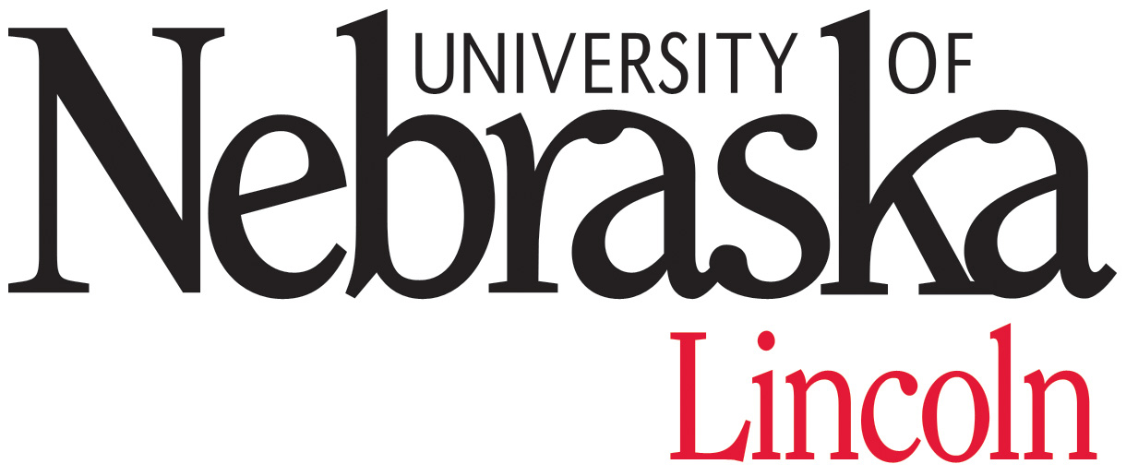

P3/NIAC Intern Program APPLICATION

Please type or print in black ink.

Name: _______ ______________________ ___ ____________________________________
Mr./Ms. First M.I. Last

Current Address: ________________________________________ ( )______________
Street Telephone This is my Cell Phone
_____________________ _____ ______________
City State Zip

Permanent Address: ________________________________________
Street
_____________________ _____ ______________ ( )_________________
City State Zip Telephone This is my Cell Phone

E-mail address: ____________________________________ Date of Birth: _______________________________

UNL Student I.D. Number: ____________________________________

U.S. Citizen or Permanent Resident Alien: Yes No

Gender: M F

Emergency Contact: ____________________ ________________ ________________ ___________
Name Home Telephone Work Telephone Relationship

College/University Attended  Name and Location | Dates Attended | Degree Expected or Received | Expected Graduation Date

Academic Major: ____________________ GPA _________ Math/Science/Engr. GPA _________

Present Class Standing: Junior Senior Graduating Senior Graduate Student

I affirm that the information in this application is accurate to the best of my knowledge. I also give permission to share the information in this application with potential P3 program business clients.

________________________________________________ _____________________________
Name/Signature Date

INCOMPLETE APPLICATIONS WILL NOT BE CONSIDERED

Supplemental Application Questions

Description of Interest

Please provide a typed description of your interest in the Partners in Pollution Prevention/Nebraska Industrial Center Assessment program on an additional sheet of paper by answering all the questions below. Number your responses to each of the six questions. Limit your answer to each question to no more than a paragraph. Several questions can be answered with a single sentence or phrase. Each internship position is different. This information helps us learn about you and identify possible intern placements.

- Why do you want to be part of the P3 and NIAC program?

- What qualifications do you have that will help you to succeed in the program? These qualifications may include your course work, volunteer and work experience, work habits, personality traits, interests or hobbies away from school, environmental ethic, etc.

- This program is unique in that it provides a number of different learning experiences. What are the top two or three areas/topics that you want to be personally challenged to improve by participating in the P3/NIAC learning experience? Briefly explain. Examples of topics include (but are not limited to): pollution prevention theory/methods, sustainable manufacturing, energy efficiency, food processing, technical writing, applied research, interpersonal communications, time management, and making public presentations.

- We place students throughout the state of Nebraska in both rural and urban areas. Note that the majority of positions are for clients outside of the Lincoln/Omaha metro areas. For example, it is anticipated that there will be several in the Columbus/Holdrege/Grand Island region and one in Ogallala. Do you have a strong preference as to where you would like to work in Nebraska? If so, please explain.

- Some program participants will be required to travel within the community or the region that they are assigned. Do you have a valid US driver’s license? Do you have access to an automobile?

- Is there anything else about you that will help us in the selection process?

Recommendation for the Partners in Pollution Prevention / Nebraska Industrial Assessment Center Programs

Name of Applicant __________________________________________________
Name of Reference _________________________________________ Phone Number ____________________
Relationship of Reference to Applicant __________________________________
Under the Family Educational Rights and Privacy Act, university students have the right to inspect their files upon request. Please sign one of the following statements so that the person writing this letter of recommendation will know if it will be held in confidence or whether it will be open to your inspection upon request.

I retain my right to read this letter I waive my right of access to this letter
___________________________________________ __________________________________________
Student Name/Signature Date Student Name/Signature Date

REFERENCE
Please complete the following information:
I would rate the applicant among the upper _____ % of previous students I have known.

For each qualification below, please circle the word that best describes the applicant:
Initiative/Self Starter:
Nearly all the time Needs occasional stimulation Needs frequent attention/motivation
Academic Ability:
Outstanding Upper 10% Upper 25% Average Below Average Insufficient Info
Oral Communication with Teachers and/or Supervisors:
Excellent Very Good Average Below Average
Quality of Written Reports:
Excellent Very Good Average Below Average Insufficient Info
Ability to Solve Open-Ended Problems:
Excellent Very Good Average Below Average Insufficient Info
The students in this program will work side-by-side with UNL Faculty, regulatory officials, and
business staff to provide pollution prevention assistance to industries in Nebraska. The technical assistance will involve significant oral and written components, require a student to be a self-starter, and require the student to work with a wide range of personalities.
Please describe any traits that the student has that might have an important influence on his/her success in this program. Comment either below or on an additional sheet.

Please return the reference form to: Dr. Bruce Dvorak  UNL  W181 NH  Lincoln, NE 68588-0531
Or e-mail to: bdvorak1@unl.edu

Recommendation for the Partners in Pollution Prevention / Nebraska Industrial Assessment Center Programs

Name of Applicant __________________________________________________
Name of Reference _________________________________________ Phone Number ____________________
Relationship of Reference to Applicant __________________________________
Under the Family Educational Rights and Privacy Act, university students have the right to inspect their files upon request. Please sign one of the following statements so that the person writing this letter of recommendation will know if it will be held in confidence or whether it will be open to your inspection upon request.

I retain my right to read this letter I waive my right of access to this letter
___________________________________________ __________________________________________
Student Name/Signature Date Student Name/Signature Date

REFERENCE
Please complete the following information:
I would rate the applicant among the upper _____ % of previous students I have known.

For each qualification below, please circle the word that best describes the applicant:
Initiative/Self Starter:
Nearly all the time Needs occasional stimulation Needs frequent attention/motivation
Academic Ability:
Outstanding Upper 10% Upper 25% Average Below Average Insufficient Info
Oral Communication with Teachers and/or Supervisors:
Excellent Very Good Average Below Average
Quality of Written Reports:
Excellent Very Good Average Below Average Insufficient Info
Ability to Solve Open-Ended Problems:
Excellent Very Good Average Below Average Insufficient Info
The students in this program will work side-by-side with UNL Faculty, regulatory officials, and
business staff to provide pollution prevention assistance to industries in Nebraska. The technical assistance will involve significant oral and written components, require a student to be a self-starter, and require the student to work with a wide range of personalities.
Please describe any traits that the student has that might have an important influence on his/her success in this program. Comment either below or on an additional sheet.

Please return the reference form to: Dr. Bruce Dvorak  UNL  W181 NH  Lincoln, NE 68588-0531
or e-mail to: bdvorak1@unl.edu

